TECHNICAL UNIVERSITY OF GABROVO

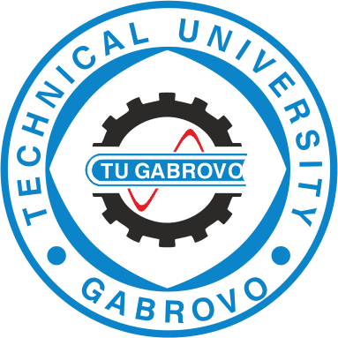

invitation

Annual Student Scientific Session

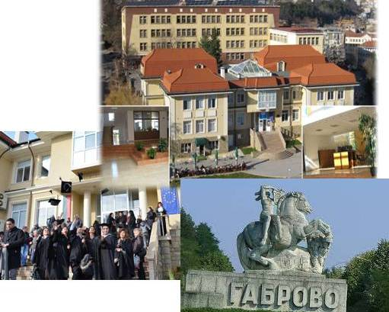

Technical University of Gabrovo

18th October, 2019

GABROVO

ORGANIZING COMMITTEE

Chairman: Assoc. Prof. Iliya Zhelezarov, Ph.D.
Vice Rector in charge of research and development

Members: Assoc. Prof.Milena Koleva, Ph.D.
Assoc. Prof. Totyo Iliev, Ph.D.
Assoc. Prof. Hristo Hristov, Ph.D.

Technical Assistant:
Petya Peneva, MA

SCIENTIFIC PROGRAMME:
- Scientific papers and reports /up to 15 mins./;
- Discussions and debates.

Conference Languages:
- Bulgarian, English, German and Russian

TOPICS:

- Electrical Engineering
- Communication Engineering and Technologies
- Automation and Computer Systems
- Design of Machines and Instruments
- Technologies in Mechanical Engineering end Textile Production
- Hydraulics, Pneumatics and Heat Engineering
- Economics and Finance
- Social Sciences and Humanities
- Mathematics and Physic
- Chemistry, Ecology

OBLIGATORY REQUIREMENTS FOR THE AUTHORS
The complete text of the papers should be prepared using Winword (A4-size, two-column text) and should not exceed 6 pages, including figures and tables. The papers need to be sent to sns@tugab.bg

IMPORTANT DATES:

11.10.2019 Deadline for submitting the complete papers
18.10.2019 Registration of participants and opening of the session

Conference Fee:
There is no fee for first participation

The Student Scientific Session 2019 is organized with the support of
"Europe direct Gabrovo"

