 | Technical University of Gabrovo | Students Scientific Session  18 October, 2019

PAPER TITLE

Author
Specialty, Department
University

Resume: text, text, text, text, text, text, text, text, text, text, text, text, text, text, text, text, text, text, text, text, text, text, text, text, text.

Key words:

INTRODUCTION
Text of the Introduction

EXPOSE
Text of the Expose

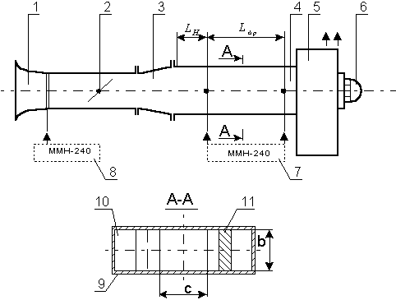
Figure 1. Figure title

Table 1. Table title

Formula (1)

CONCLUSION
Text of the Conclusion

Literature

[1] Duflou, J. R. and others; Methods for the sequencing of sheet metal bending operations, International Journal of Production Research, 37 (14),1999, 3185-3202
[2] D. P. Anderson, J. Cobb, E. Korpela, M. Lebofsky, and D. Werthimer, SETI@home: An experiment in public-resource computing, Communications of the ACM, Nov. 2002, Vol. 45 No. 11, pp. 56-61.

Appreciation to:

